## Lab 2 — CloudFront Caching and Invalidation

1. Create an S3 bucket (keep Block Public Access on). Upload `index.html` containing `Version 1`.
2. Create a CloudFront distribution with the bucket as origin, using Origin Access Control. Apply the generated bucket policy.
3. Wait for `Deployed`. Load the CloudFront URL — you should see `Version 1`.
4. Overwrite `index.html` in S3 with `Version 2`.
5. Reload the CloudFront URL. You still see `Version 1`. Sit with that.
6. Run `curl -I <cloudfront-url>` and read the `X-Cache` and `Age` headers.
7. Create an invalidation for `/index.html`. Wait for it to complete.
8. Reload. You now see `Version 2`. Check `X-Cache` again.
9. Optional: set `Cache-Control: max-age=30` on the S3 object and watch the TTL behavior change.

**Cleanup:** disable distribution → delete it → empty and delete bucket.

Step 1: Create a S3 bucket
Open AWS console --- open S3 --- create bucket --- enter name --- enter region --- keep ALCs disabled --- check block all public access --- bucket versioning (disable) --- default encryption (Server-side encryption with Amazon S3 managed keys (SSE-S3)) --- bucket key (enable) --- create bucket

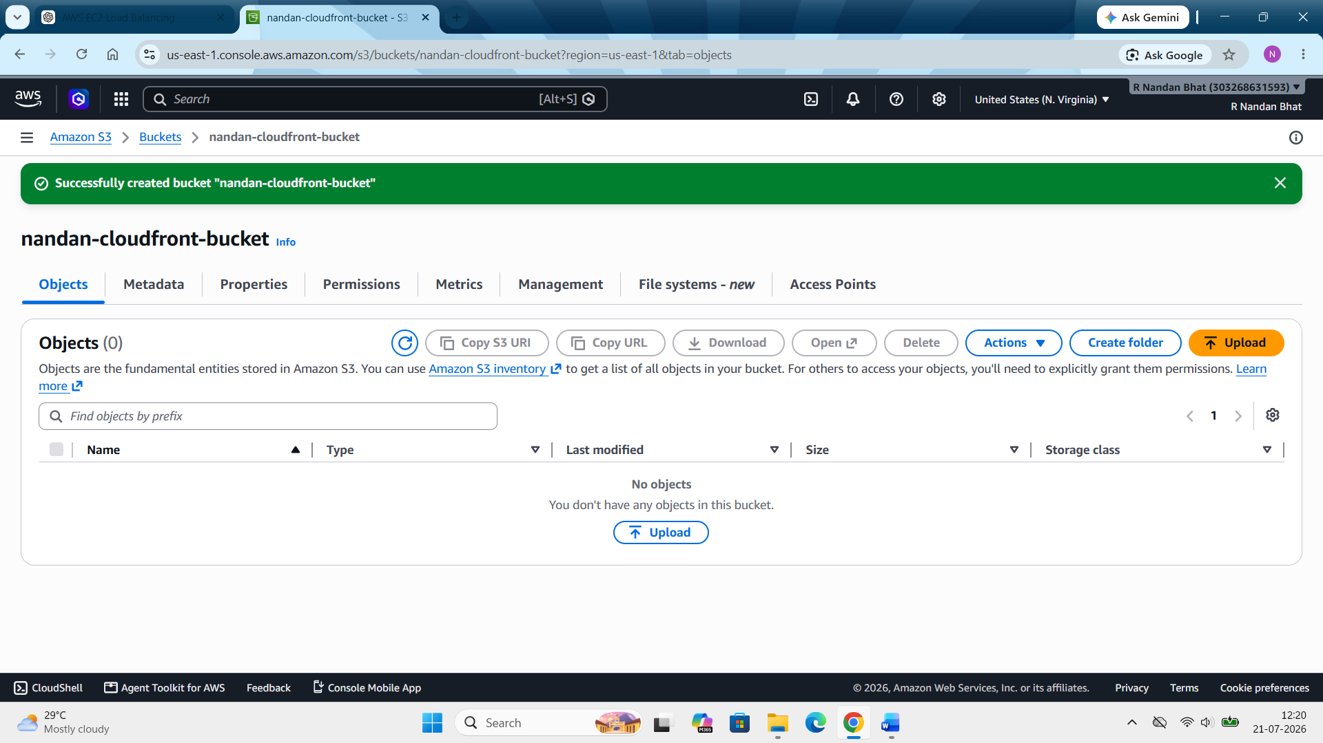

Step 2: Create index.html file and upload the same
Open notepad --- Write the content (version 1) --- save and name it “index.html” --- open S3 bucket ---upload ---add files --- upload
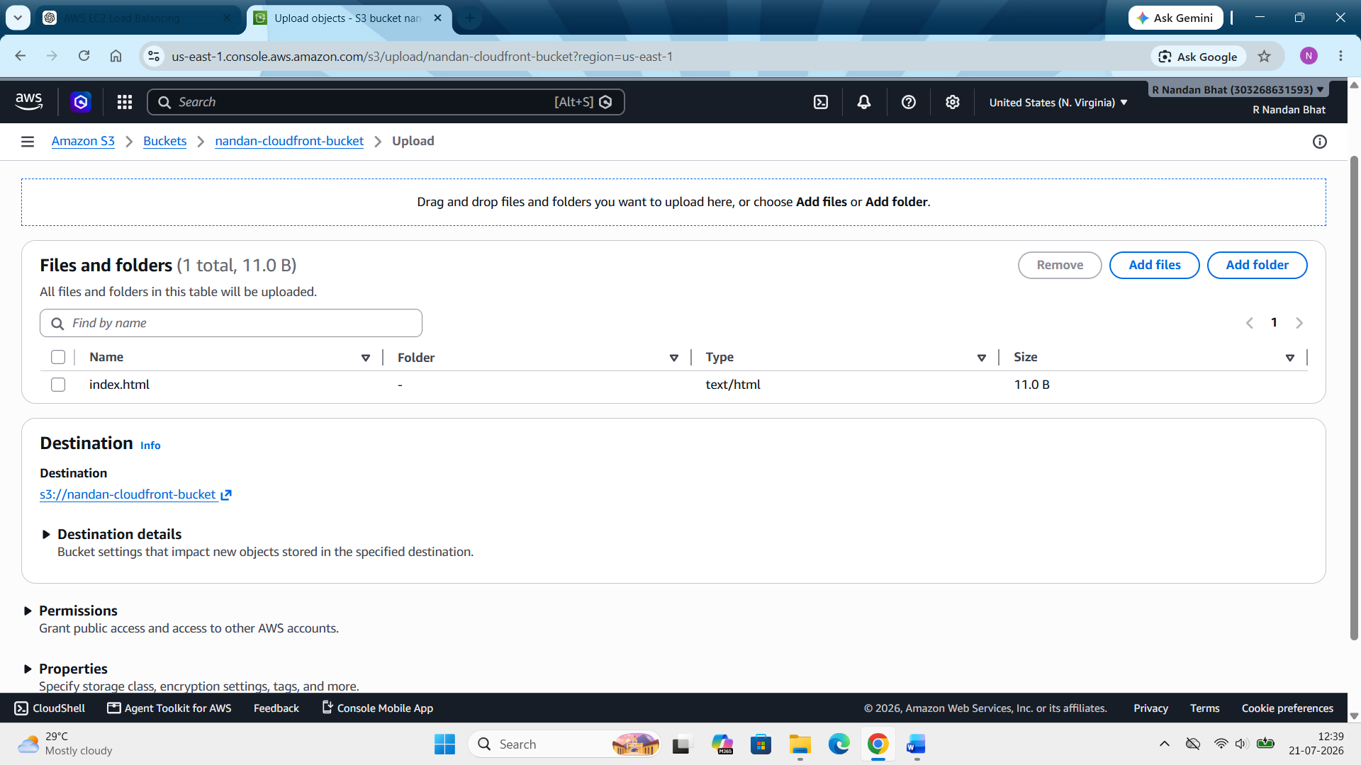

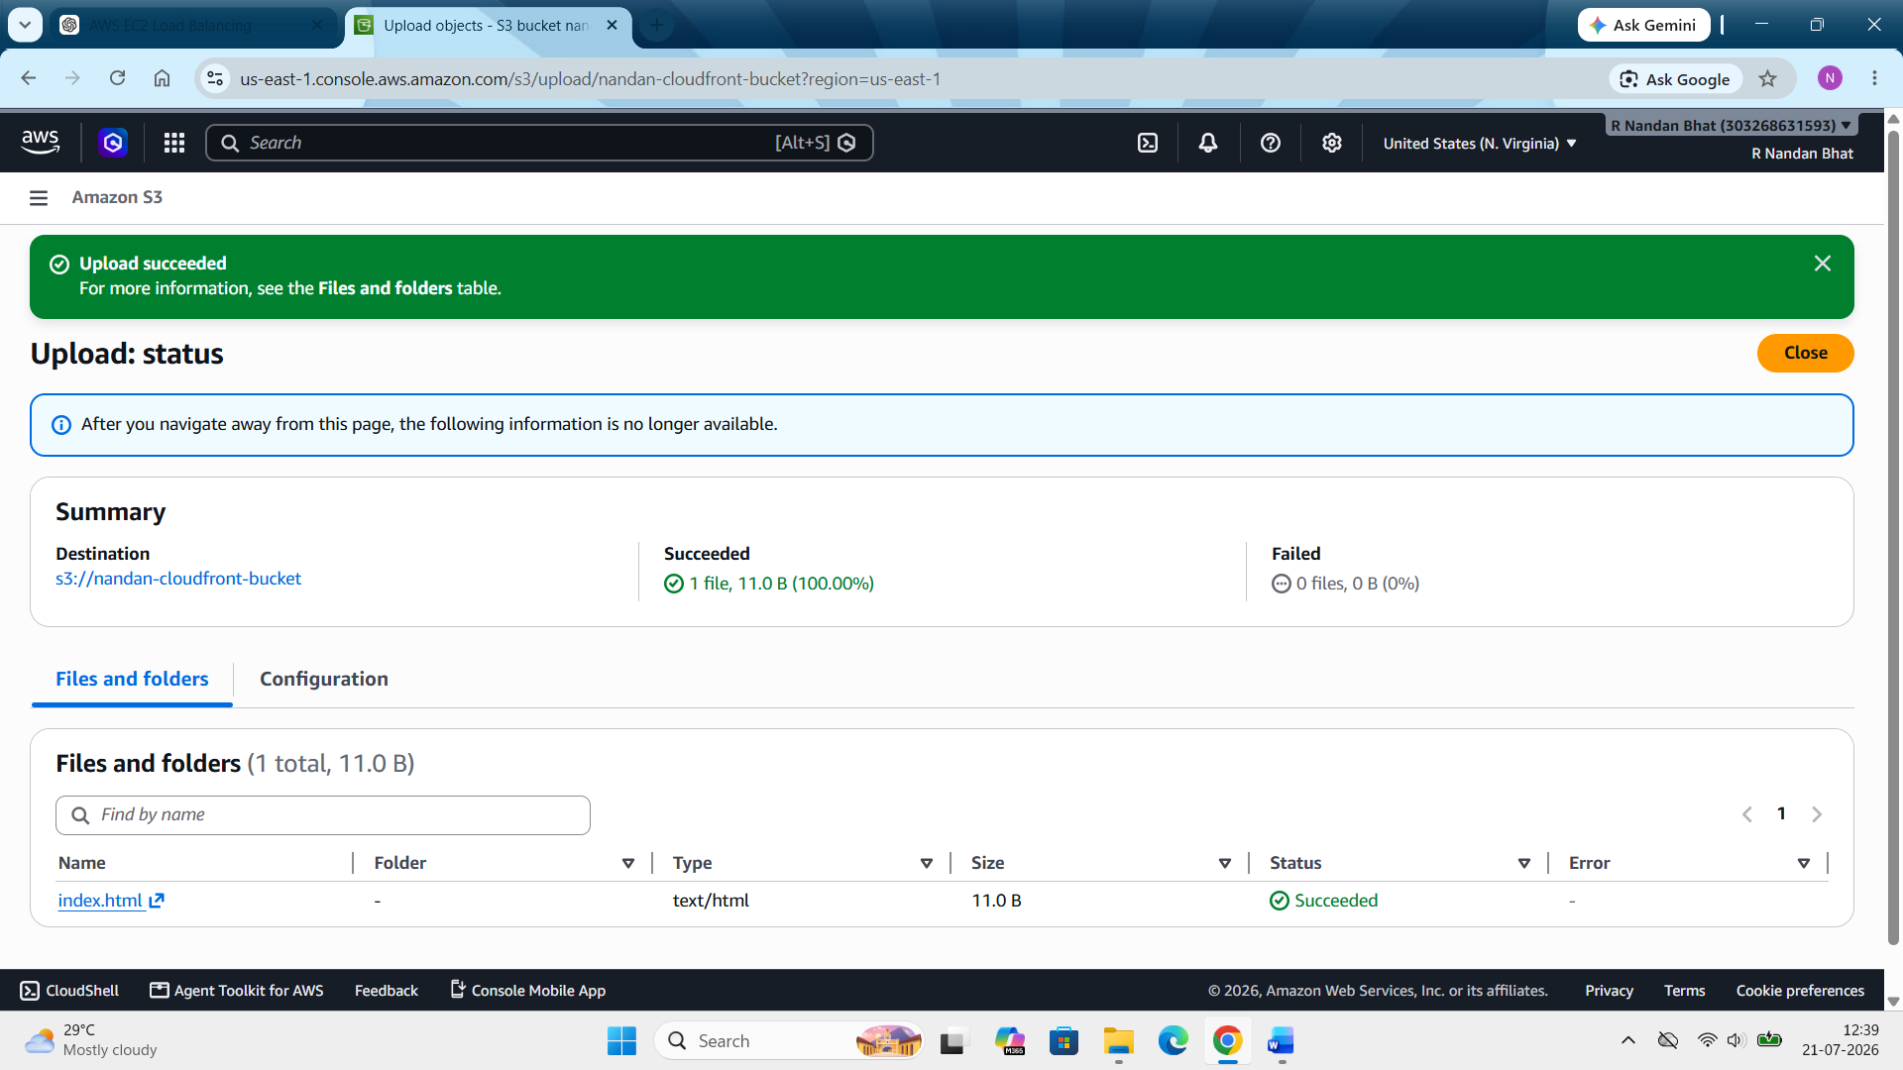

Step 3: Create a CloudFront distribution with the bucket as origin, using Origin Access Control. Apply the generated bucket policy.
Open cloud front --- create distribution --- origin type (S3 bucket) --- browse S3 --- select the create bucket --- rest keep default --- next ---enable security --- web application firewall (Do not enable security protections) --- next --- check everything is correct --- create distribution
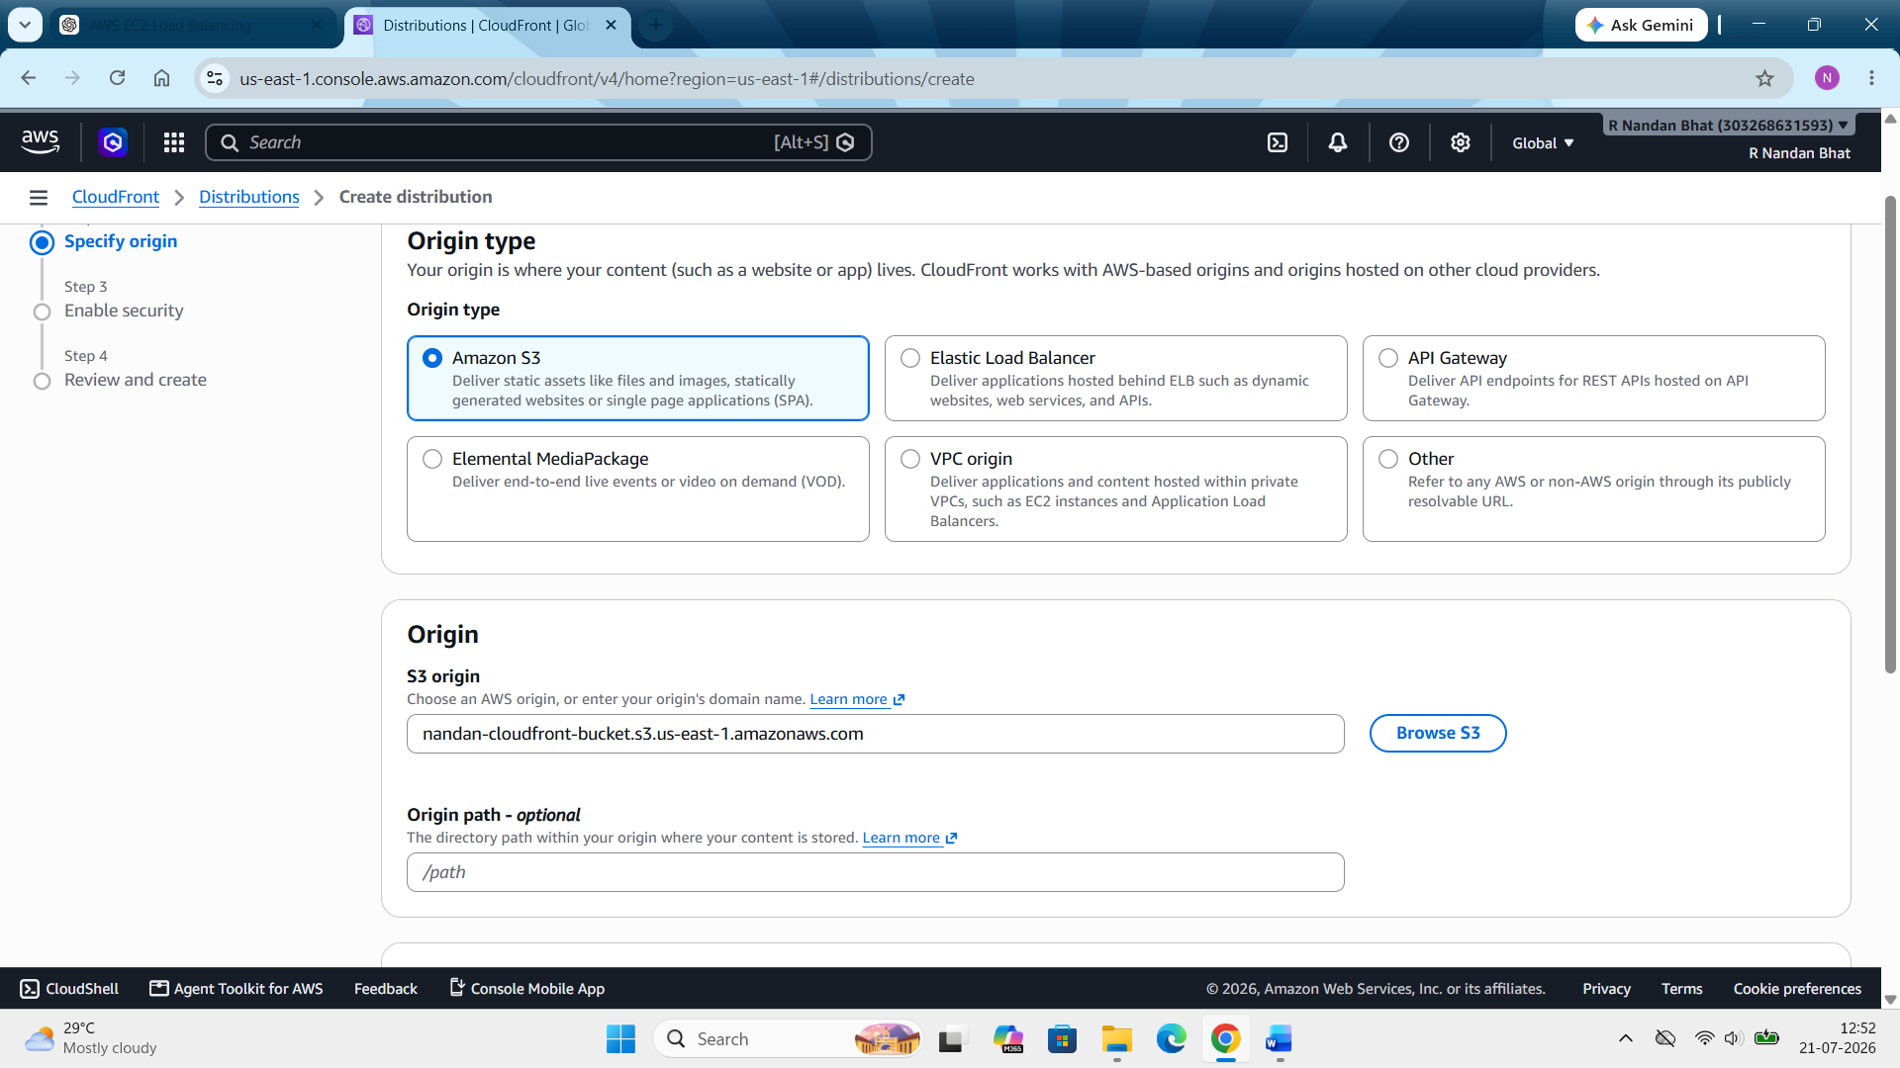

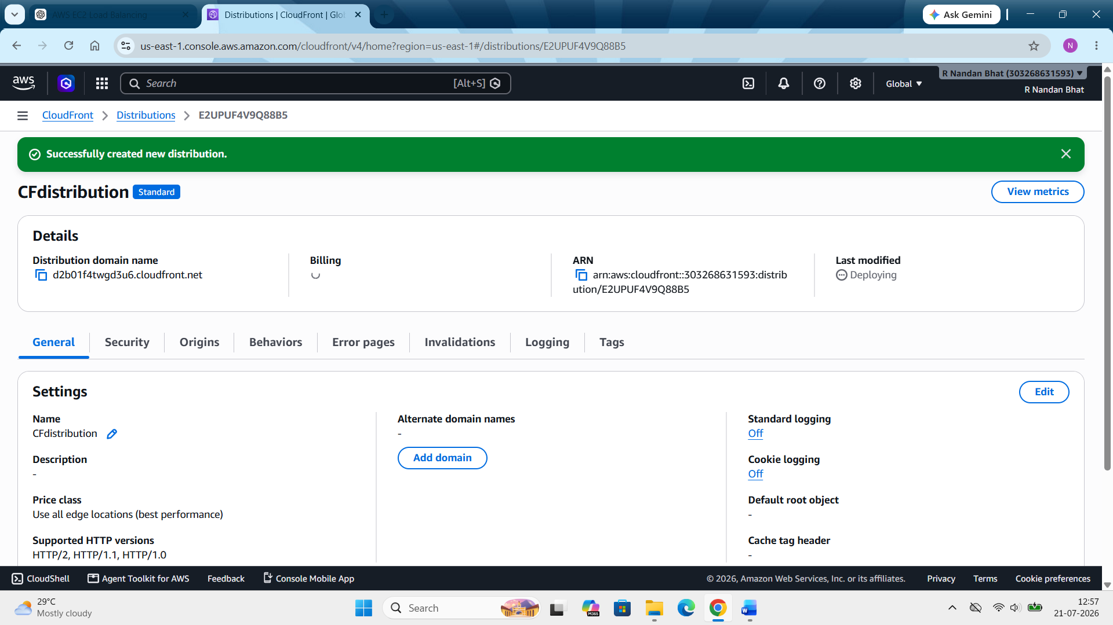

Wait for 5 -15 min for last modification to turn from deploying to deployed/enabled. Also in default root object add the file name (index.html).
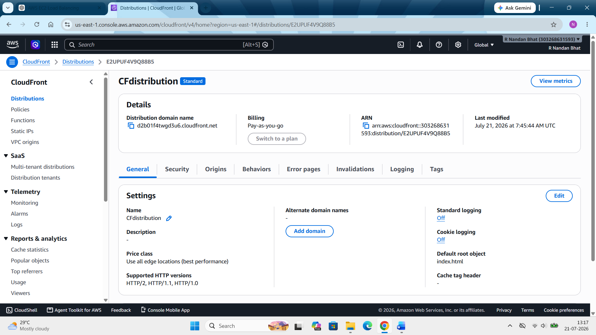

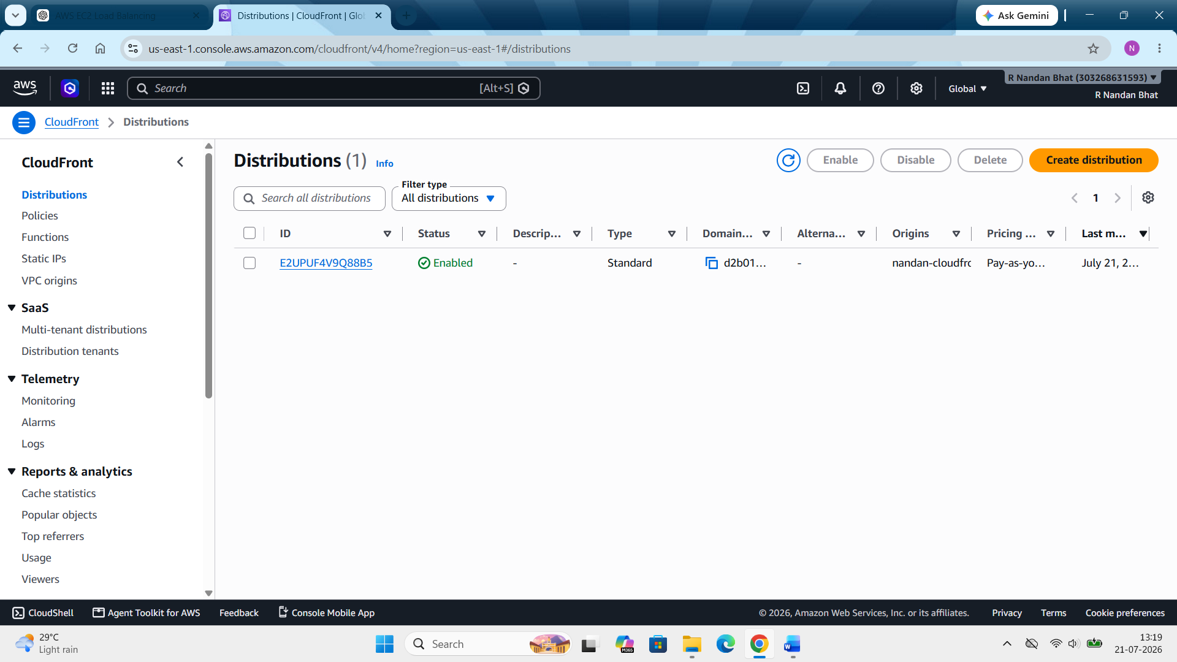

Step 4: Now copy the “distribution domain name” and paste it in the browser.
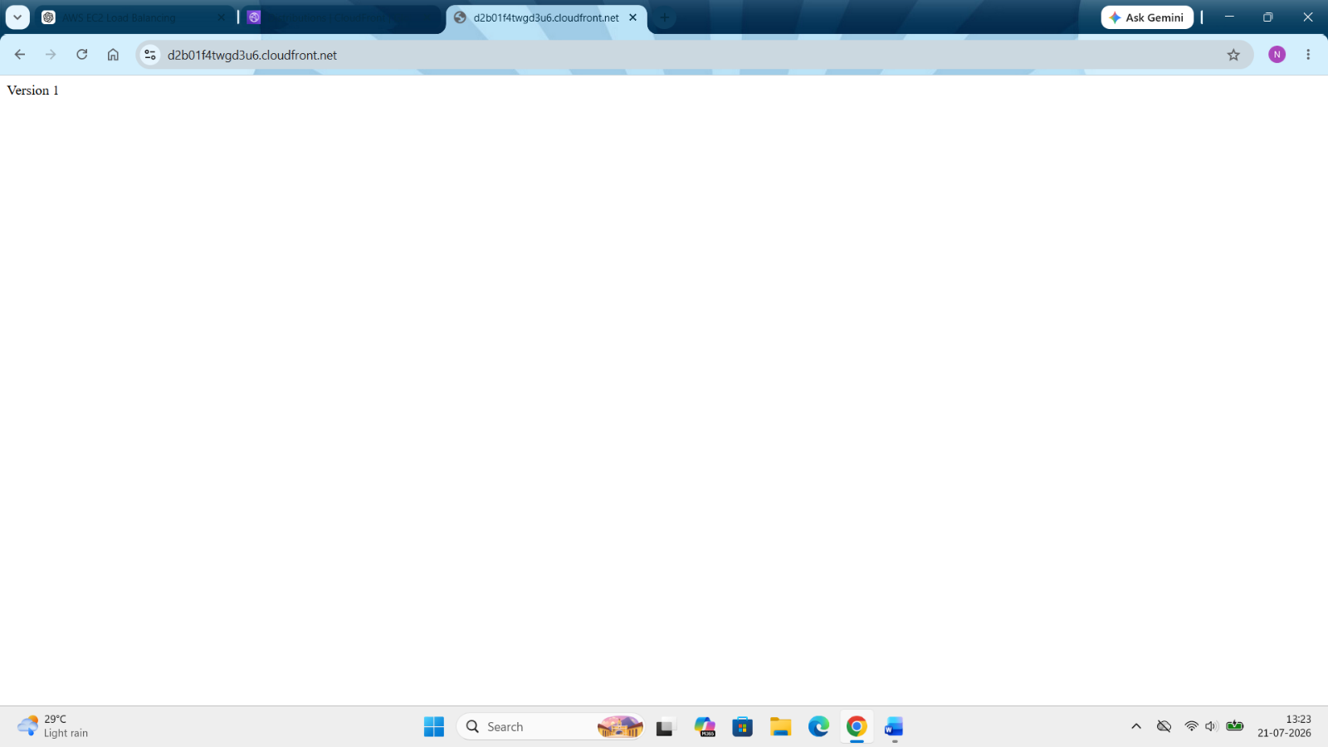

Step 5: Overwrite index.html in S3 with Version 2
Open index.html --- change the version 1 to version 2 --- save it --- upload to S3 bucket again --- upload

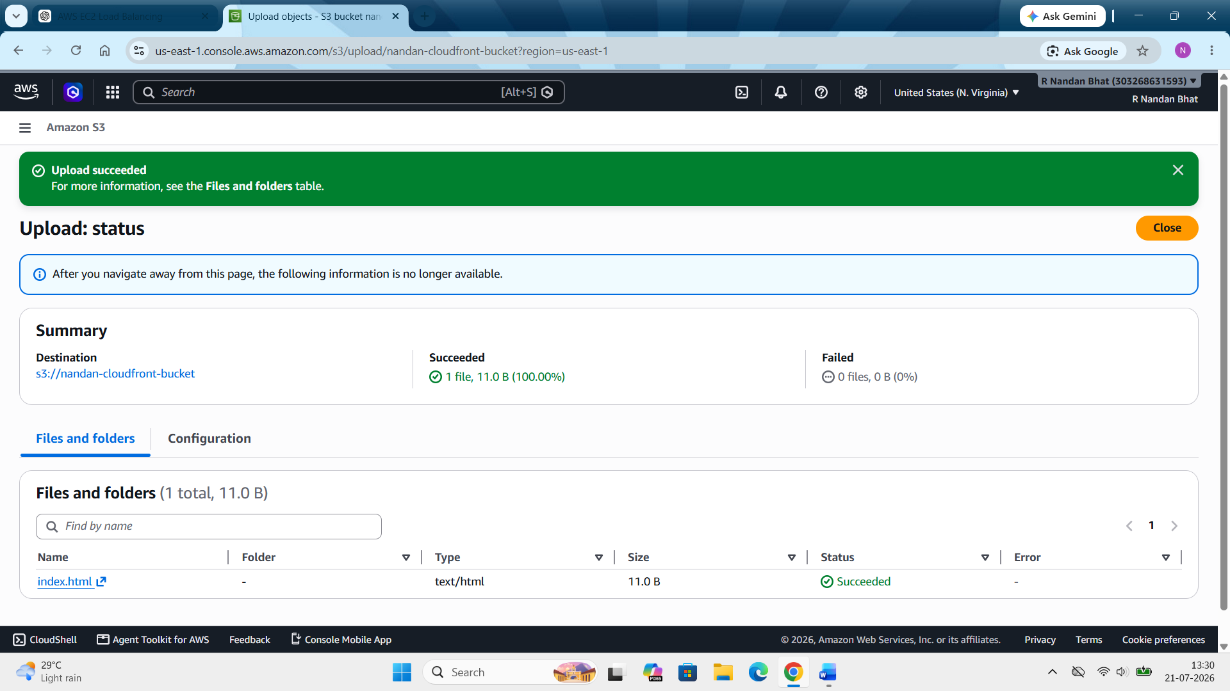

Step 6: After the change reupload the cloudfront URL again.
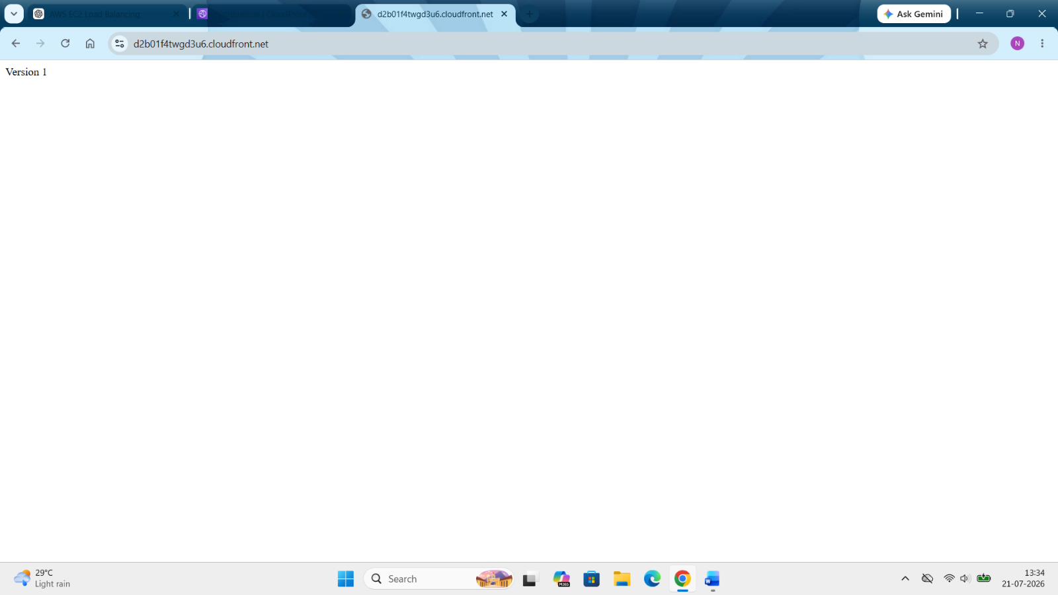
We again see Version 1. This is because cloud front is serving the cache copy. S3 now contains Version 2. CloudFront still has Version 1 stored in its cache. So CloudFront serves the cached copy instead of fetching the updated file from S3. Keep it like that.
Step 7: Now open command prompt ---- run curl -I https://d2b01f4twgd3u6.cloudfront.net --- look for header X-cache & age --- X-Cache: Miss from cloudfront (This means CloudFront did not serve the file from its cache for this request. Instead, it fetched the latest object from the origin (your S3 bucket) and then cached it.)
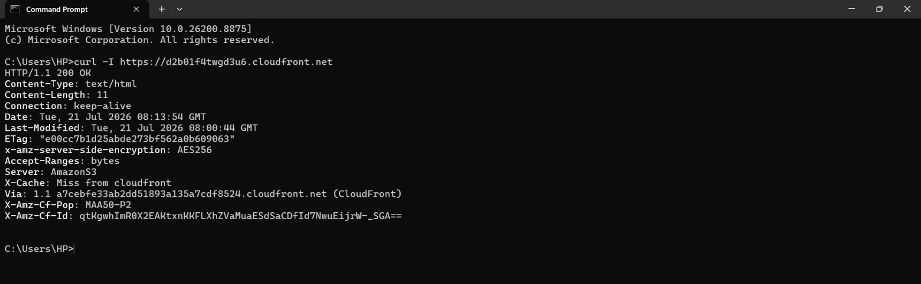

Note:
- The lab says to "read the X-Cache and Age headers." It doesn't require you to get a specific value like Hit. Depending on timing, cache state, or the request type, seeing Miss is normal.
- Your response doesn't include an Age header. That's also expected with a cache miss. Since CloudFront had to fetch the object from S3, there wasn't an existing cached object with an age to report.

Step 8: Create an invalidation for /index.html. Wait for it to complete.
Open cloudfront --- distributions ---select the created one --- invalidations --- create invalidation --- by path --- enter “/index.html” --- click create invalidation
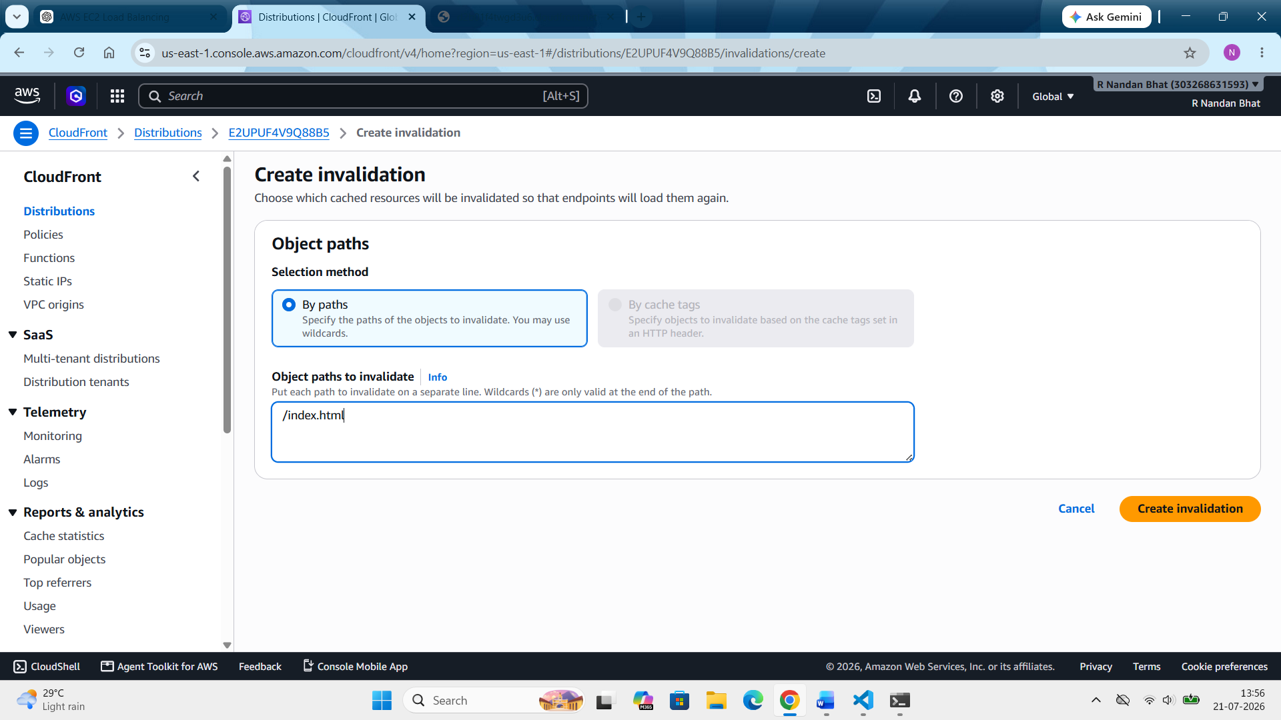

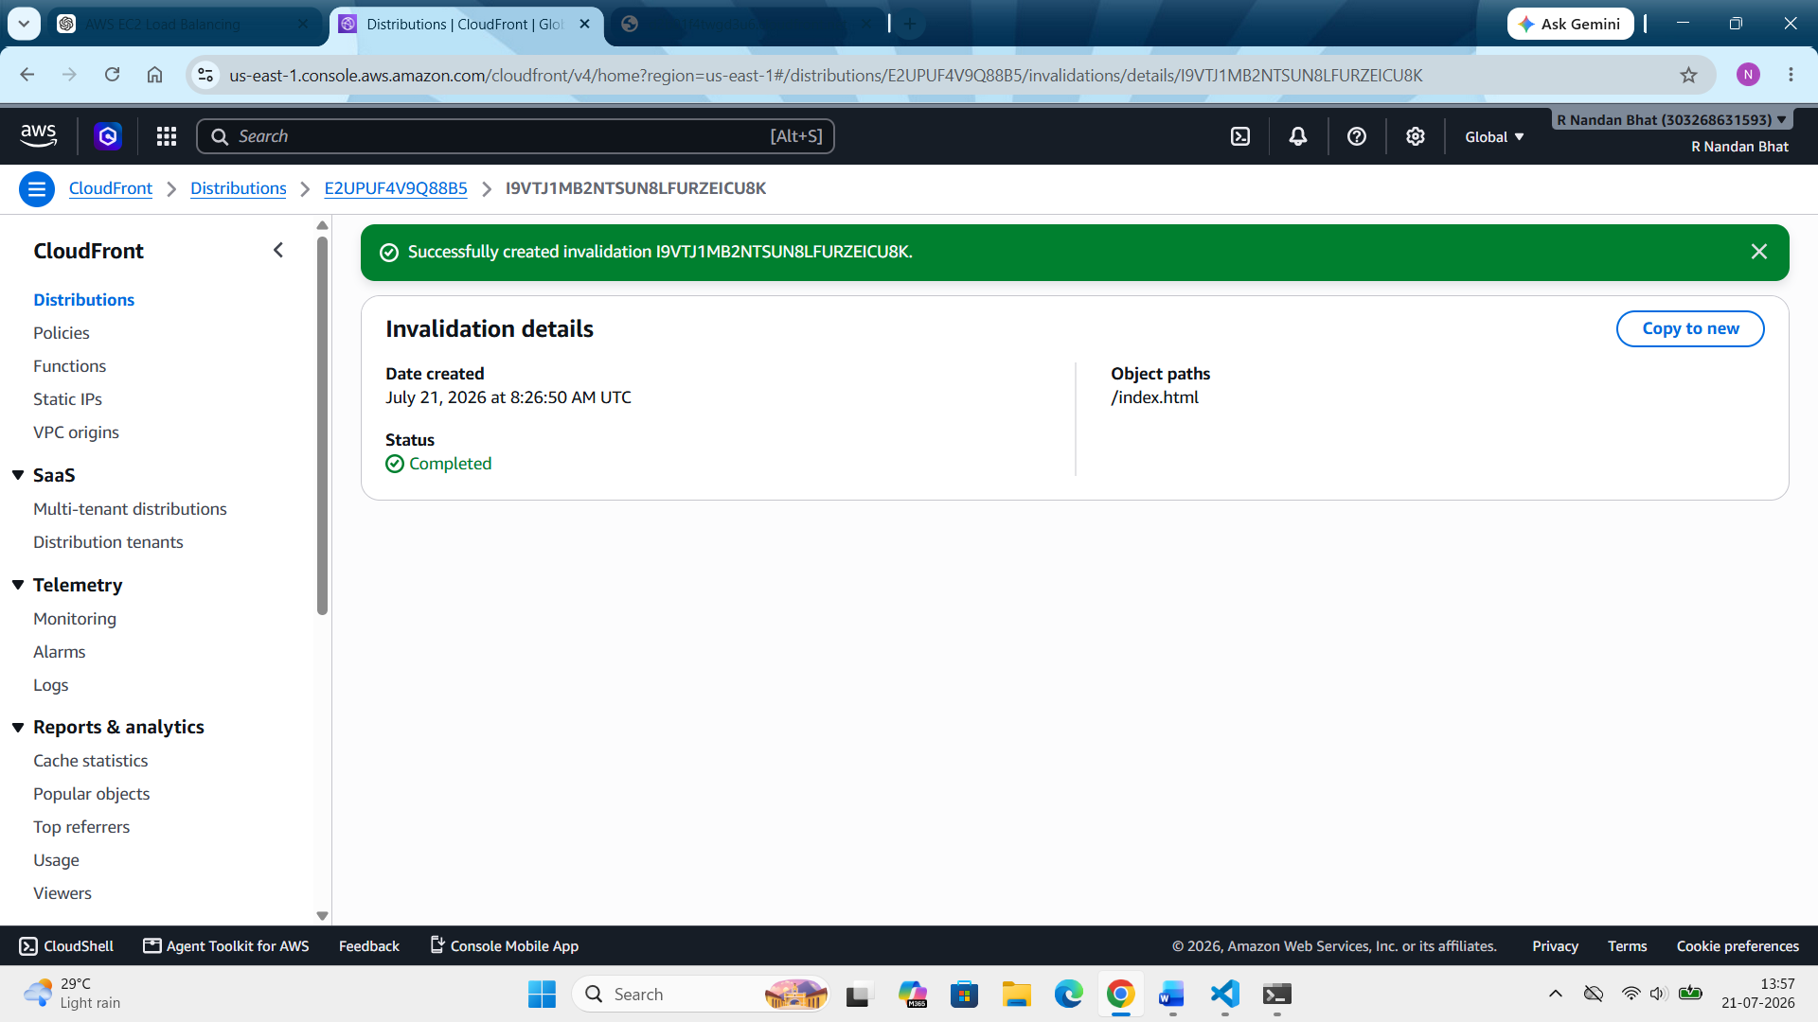
- This is actually the main concept of the lab. CloudFront invalidation is used to tell CloudFront to forget its cached copy and fetch a fresh one from S3.
- We create an invalidation only when we need users to receive the updated content immediately. Otherwise, CloudFront automatically refreshes its cache after the cache TTL expires. In many production environments, versioned filenames are used instead of frequent invalidations.
Step 9: Open the cloud front URL again. Now we see version 2.
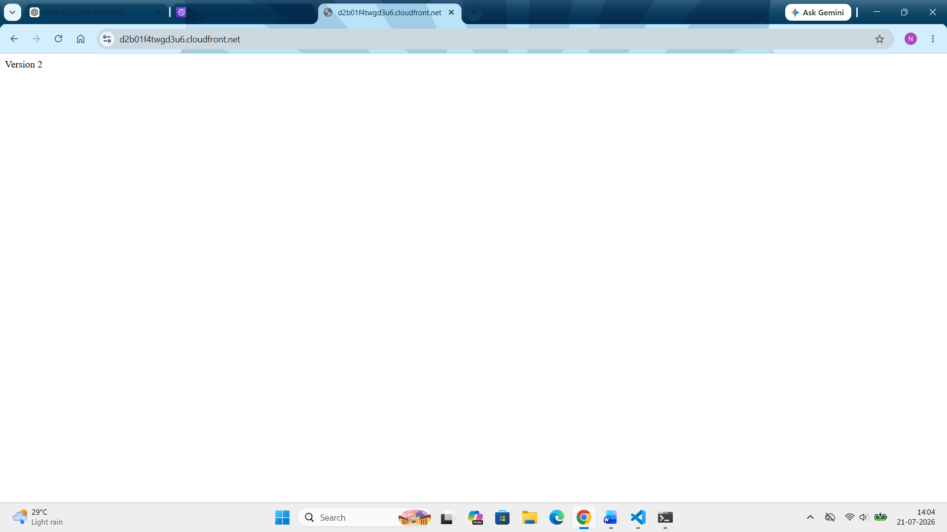

Note: Delete everything. Clean up as we can be charged if it keeps running.

